Project Design Phase-II
Technology Stack (Architecture & Stack)

Date | 5 April 2026
Team ID | SWTID-2026-5153
Project Name | Automating employee data
Maximum Marks | 4 Marks

Technical Architecture:
The technical architecture for the Automating Employee Data project defines a secure, scalable system with user interface, backend services, database, and integrations to automate employee data management.

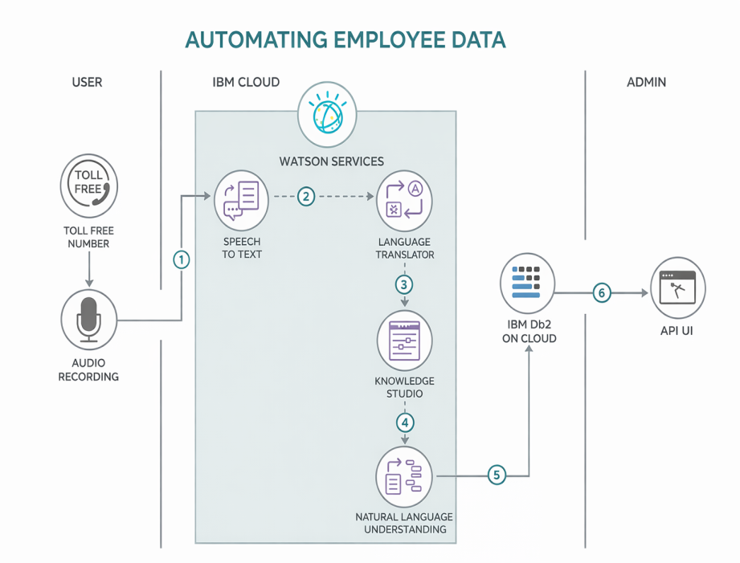

Table-1 : Components & Technologies:
S.No | Component | Description | Technology
 | User interface | Employee-facing interface for entering, updating, and viewing employee details. Admin dashboard for HR and management to monitor records, attendance, payroll, and reports. | HTML5, CSS3, JavaScript, React JS, Bootstrap
 | Application Logic-1 | Core business logic for employee registration, attendance tracking, payroll processing, leave management, and employee record validation | Python, Flask / Java Spring Boot
 | Application Logic-2 | Converts employee voice inputs into text for automated data entry or attendance logging through speech. | IBM Watson Speech to Text Service
 | Application Logic-3 | AI assistant for answering employee queries related to leave balance, salary, attendance, and company policies. | IBM Watson Assistant
 | Database | Stores employee information such as employee ID, name, department, attendance, payroll, leave records, and login credentials. | MySQL / PostgreSQL
 | Cloud Database | Cloud-based storage for centralized employee data access and backup. | IBM Db2 on Cloud / IBM Cloudant
 | File Storage | Stores employee-related documents such as resumes, ID proof, salary slips, certificates, and attendance reports. | IBM Cloud Object Storage / Local File System
 | External API-1 | Sends SMS or email notifications to employees for attendance, leave approval, payroll, and announcements. | Twilio API, SendGrid API
 | External API-2 | Employee identity verification and validation using government or company records. | Aadhaar Verification API / Employee ID API
 | Machine Learning Model | Predicts employee attrition, attendance trends, and performance analysis based on historical data. | IBM Watson Machine Learning, Scikit-learn
 | Infrastructure (Server / Cloud) | Application deployment in cloud with separate services for frontend, backend, database, and AI modules. | IBM Cloud, Docker, Kubernetes, Cloud Foundry

Table-2: Application Characteristics:
S.No | Characteristics | Description | Technology
 | Open-Source Frameworks | Open-source frameworks are used for developing the frontend, backend, APIs, and machine learning modules of the employee automation system. | React JS, Flask, Spring Boot, Node.js, Scikit-learn
 | Security Implementations | Secure login and role-based access for employees, HR, and admin users. Passwords are encrypted and all employee records are protected during transmission and storage. | SHA-256, AES Encryption, HTTPS, JWT Authentication, IBM IAM, OWASP Security Standards
 | Scalable Architecture | The application is designed using a 3-tier architecture with separate presentation, application, and database layers. Individual services can scale independently. | Microservices Architecture, Docker, Kubernetes
 | Availability | The system remains available even during high employee usage by using multiple application servers and cloud database backups. | Load Balancer, IBM Cloud Availability Zones, Distributed Servers
 | Performance | Fast response time is maintained for employee search, payroll reports, and attendance logs using caching and optimized database queries. | Redis Cache, CDN, Optimized SQL Queries

